EVO Life Cycle

by

Ken Shoulders ©2006

Abstract
An EVO, or Exotic Vacuum Object, begins its life by accreting electrons extracted from gaseous or solid atoms. It then self-transforms into a coherent structure behaving as an entity functioning at greatly reduced expressed charge compared to the number of electrons either put into it or extracted from it at this stage in its life. Charge to mass ratio measurements on the EVO remain the same as that of electrons implying that the mass was also reduced. Part of the process of this transmogrification involves electron emission within a narrow energy range around 2 KeV. If this initial stage of formation is left undisturbed during a brief flight at high velocity, it transforms again into a non-emitting Black state with even further reduction in expressed charge. When this black EVO is reduced in velocity to minimize interaction with matter, the entity becomes virtually undetectable using sensitive particle and charge sensing apparatus. This measurement is in apparent violation of conventional charge and energy conservation laws. While it is clearly evident through various measurements that this disappearance happens in gas up to at least atmospheric pressure, it is speculated that the effect extends to solids thus creating an unexpected form of both transparency as well as presenting a new form of very energetic active shielding from both projectiles and directed beam weapons. A new program for increasing experimental activity is described.

Overview: Writings by the author published on the Internet at: www.svn.net/krscfs/ discuss many of the behavioral aspects of EVOs in the role of electronic devices, propulsion and energy sources. A persistent aspect of EVO technology not strongly emphasized is their ability to reduce the effect of charge and mass on what is normally thought of as a group of electrons. When viewed in a broader sense, the effect being described could be something entirely different arising from the close association of so many electrons without positive charge compensation. Basically, this association is so unusual and unstudied that it might be appropriate to signify that a new class of particle has formed with entirely different properties from those normally studied. This note will emphasize that tack and discuss anomalous EVO behavior.

White and Black EVOs at Low Pressure: Photos of EVO behavior taken using a pinhole camera designed for viewing particle energy and motion are shown in the above referenced URL. In particular, the titles “Superluminal Particle Measurements” and “Permittivity Transitions” contain adequate information on the motion of both white and black EVOs and reference should be made to them to obviate the need for duplication in this writing.

Atmospheric Pressure EVO Activity: There is adequate proof of atmospheric pressure EVO activity in a laboratory sense and some data was published in the above referenced URL under the title of “Charge Clusters in Action”. There has also been a correlation found between laboratory EVO work and atmospheric lightning. This is indicated chiefly by the abundance of characteristic EVO strike marks found in various samples struck by lightning. In addition, examples of black EVO action have been photographed in lightning strikes. One such photo was taken by Kennan Ward and is a part of the Ansel Adams Gallery collection where retouching is not permitted as a condition of being part of the group. The annotation on the back of the photograph reads:

Kennan Ward, Davenport, CA 408/429-9533
This photo is presently available from www.kennanward.com as “Half Dome Lightning Poster” #1021 for $30.00
Kennan Ward, PO Box 42 Santa Cruz CA 95063 (831) 459-8800
July 28, 1980 Dry storm
8,000 feet elevation 55 mm micro lens
F 32 Shutter open for 8 seconds
Near sundown, overcast, sky clear under CB

This photo is published here with permission from Kennan Ward who requests it not be reused without his permission.
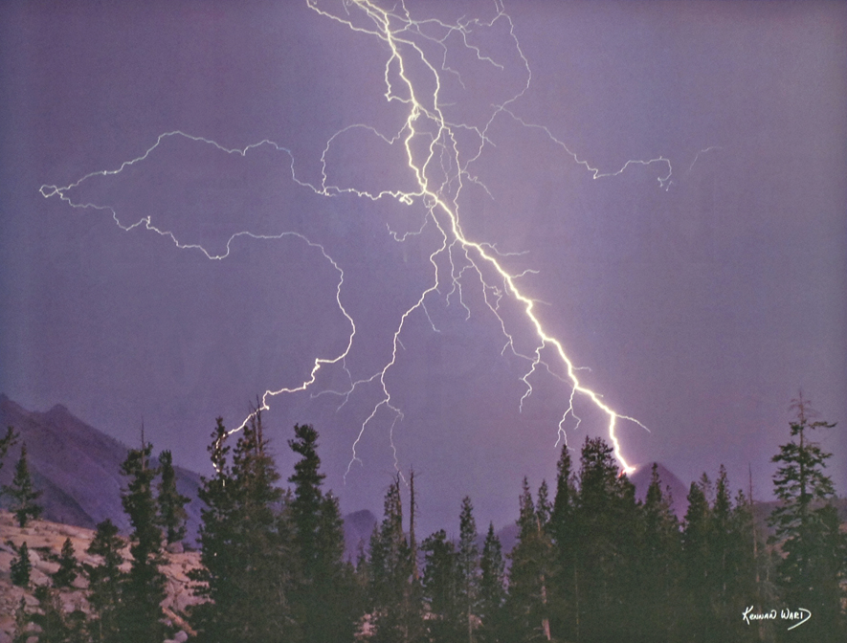
Fig. 1 is a photograph of a lightning strike on Half Dome in Yosemite National Park.
Region 1
Region 2
Region 3
Region 1
Region 2
Region 3
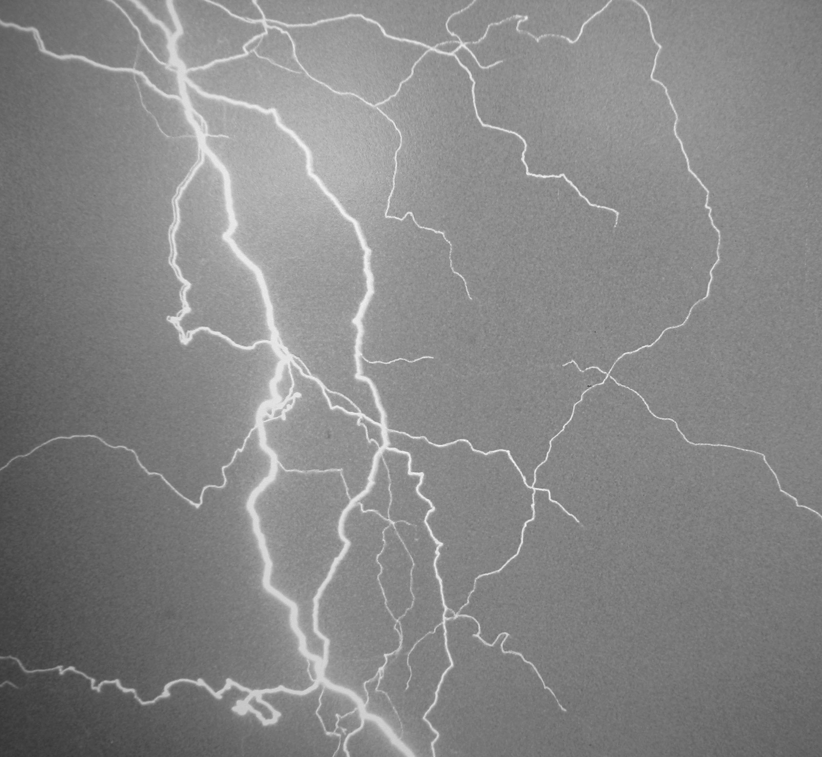

Fig. 2

Region 1, shown in Fig. 1 is magnified here and the area of interest is enclosed in the box.

Faint lines are seen to join the ends of discharge lines attributed to the lightning bolt. These are the “black” EVO regions of interest and are not due to clouds as the photographer noted no clouds were seen in this region.

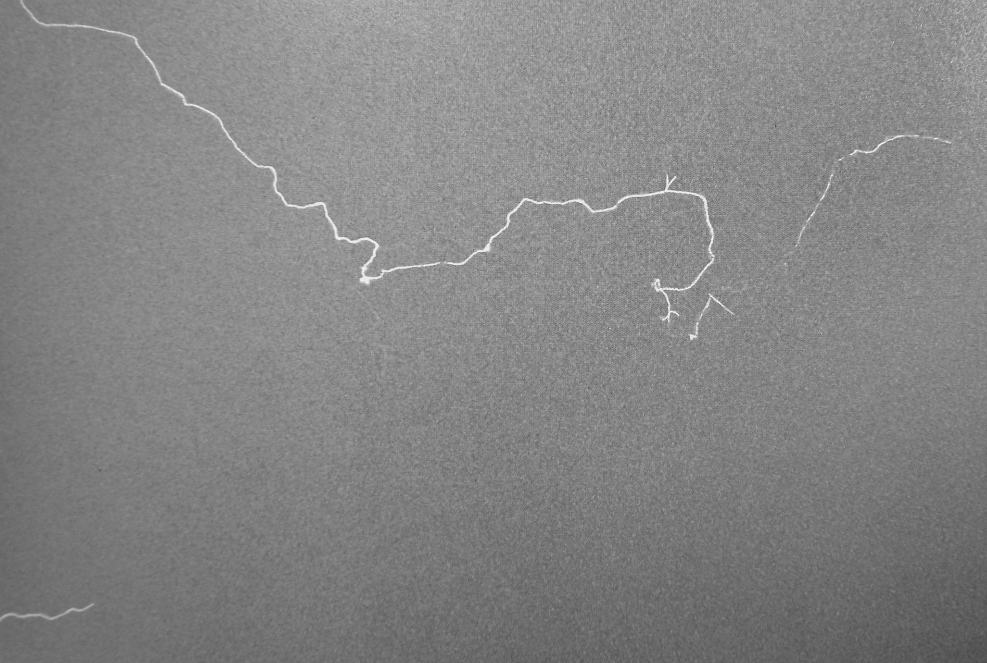

Fig. 3

Region 2, shown in Fig. 1 is magnified here and the area of interest is enclosed in the box.

The lightning bolt shows a cut at several points.

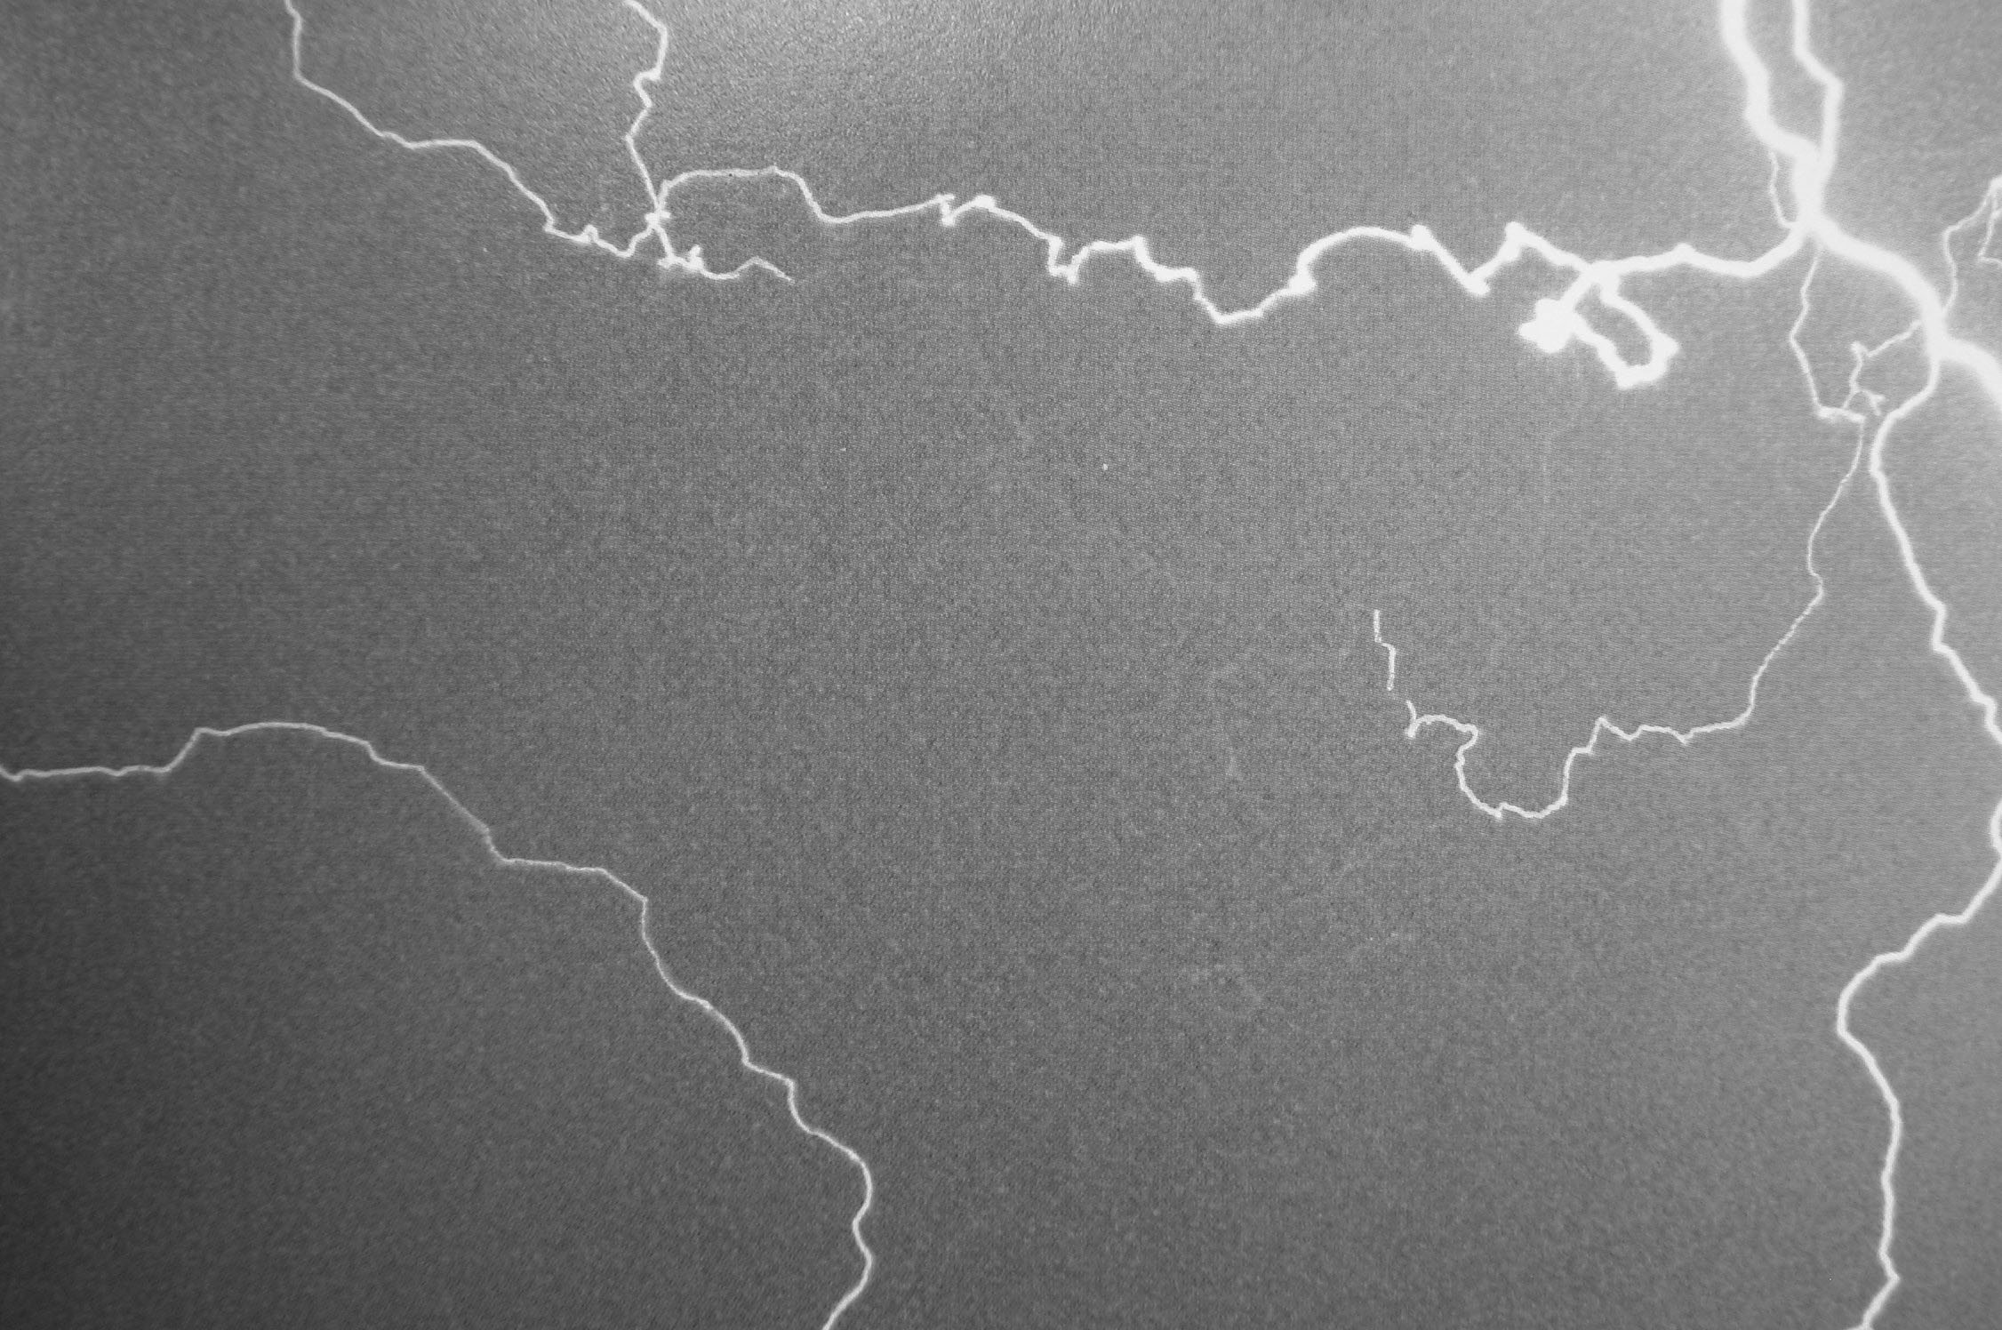

Fig. 4

Region 3, shown in Fig. 1 is magnified here and the area of interest is enclosed in the box.

Many faint lines can be seen stemming from the ends of the streamer or lightning bolt.

Velocity Reduction: As EVO velocity is reduced through electric field retardation, the expressed charge reduction effect is made obvious through deflection tests in a dc field. A serious measurement problem arises using this method because it cannot be said with surety that the ratio of EVO charge to mass, hence deflection sensitivity, remains the same with velocity change. The test applies the deflection field to a region the black EVO is known to traverse and then converts the black EVO to a white one for registration on either a phosphor or other target. The Picoscope technique used here is similar to the one described in earlier writings by Shoulders, and in particular, the EV patents issued in the early 1990’s.

From the data accumulated thus far, it appears that the deflection sensitivity remains constant, whatever that means. However, additional complication is found, in that what is seen using the deflection measurement technique, is that the induced field or coupling to the deflectors grows weaker as the velocity is reduced indicating a loss of expressed charge. This might simply be an unresolved integration problem. If this charge loss is truly the case, lowering the velocity, hence excitations, causes a close approach to zero expressed charge. The suggestion here is that to properly use very slow or cold EVOs, they must be kept excited to some yet undetermined level. The astounding fact is that whenever they are fully awakened to the white state through excitation, they regain their full and original strength implying an internal mechanism is available “knowing” or remembering the original state. It is as if the enveloped electrons have been neatly folded up into a shielded, compact form.
Postulated Interaction With Solids: With the assumption of low expressed charge, a low coupling with charged matter is likely. My belief at this time is that the EVO will equilibrate with the lattice of its container and stay available for coupling instead of disappearing completely. Still, a form of EVO transparency to matter is suggested although much more work is needed in this area before any conclusions can be drawn. A program for doing this will be outlined in a later section of this writing.

Active Shielding: Carrying the above notion of solid interactions one step further, it is interesting to view the interaction between an EVO and matter from a different vantage point. One normally thinks in terms of a moving EVO and a stationary target but that is not the only way to inspect the interaction. To wit, the EVO can be viewed as a stationary object, such as an EVO array attached to an appliance resembling an armor surround, with a projectile or energy beam moving toward the EVO structure as the target. In this case, the full stored strength of the surrounding vestment automatically comes into play as the missile enters the EVO field of influence.

The energy exerted against the intruder has a natural lower threshold allowing low velocity ingress and egress but not allowing rapidly moving matter or energy forms to enter due to their ability to excite the EVO structure locally. From simple, disrupted EVO energy measurements, an energy intensity for dishevelment of 10 ¹⁷ watts per square centimeter is available. As shown in the above-mentioned paper, “Charge Clusters in Action”, the solid dishevelment process is not thermal but instead connected to a form of cold atomic dissolution. This represents a potentially powerful bomb being used as protection but it is an open question as to whether the form of interaction is specular or scattering in nature and in which direction this energy of interaction is directed.

Experimental Work Acceleration: It can be seen from the above writing how thin the experimental work is, as an individual working alone rarely finds the whole truth. There is always a large uncertainty at the leading edge of discovery that is usually resolved by group agreement following these first indications of a direction to proceed. Up to this point, all that is available is that indicator and it is woefully inadequate for a commercial endeavor to support work on the supposition.

To alleviate this problem and provide a wider pathway to further experimental work, the author has initiated a program to make experimental methods available to anyone willing to investigate the field. This will be done by providing data, material and even complete apparatus to those wanting to participate and doing so at very low cost. This is being done by pulling together many of the simplest techniques used by the author over the years and presenting them as a series of experimental packages ranging in cost from tens of dollars to a few thousand dollars, depending largely on the degree of completion of the apparatus provided.

At the very simplest and lowest cost level, only data will be provided. The data will include how to build all apparatus including how to build the tools necessary for the apparatus construction. A more advanced kit will include many of the commonly available materials that are pre cut and ready for finishing and assembly into test apparatus. For those capable of purchasing a finished experimental setup that is pre tested, that will also be available at a higher price.

One common misconception about working in this field is that it must somehow be hard to get results. Nothing could be further from the truth and I believe the Ancient Egyptians could have done the job because they had the necessities of a metal and a dielectric, namely, copper and glass or amber. In the past I have used a technique called “Glue Glass and Brass” where all effects that need to be seen were built with apparatus using Epoxy cement, glass microscope slides or picture glass and thin brass shim stock. Occasionally, specialized items seem to be required, but a little thought always got around the supposed need.

There is a lot to see in this field and it is very easy to take a look.

