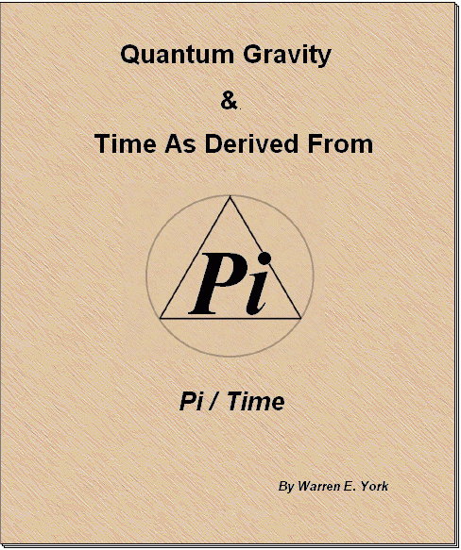

Quantum Gravity & Time As Derived From Pi/Time
( A 4D Unified Math Concept )

By
Warren E. York

Technical Editor
Ted Twietmeyer^{C}

pubmaster@charter.net
warren.york@juno.com

Copyrighted ©

TABLE OF CONTENTS

TOPIC SECTION

ABSTRACT 1.0
INTRODUCTION 2.0
DEFINITION OF QUANTUM GRAVITY 3.0
GRAVITY ATTRACTION FORCE PRINCIPLE 4.0

COMMENTARY ON DILATION 5.0
DEFINITION OF GRAVITY FORCE 6.0
THE VIRTUAL LINE 7.0
GRAVITY DESCRIPTION 8.0

UNIVERSAL GRAVITATIONAL LAW GRAPHIC 9.0
PERCEIVED KNOWLEDGE COMMENTARY 10.0
DEFINITION OF DILATION 11.0
COMMENTARY ON INTRINSIC SPIN 12.0
RELATIVISTIC TIME DILATION GRAPHICS 12.7

DEFINITION OF TIME FRAMES 13.0
SPACIAL DILATION 14.0

TABLE OF CONTENTS (Cont’d)

TOPIC SECTION

COMMENTARY ON SPACIAL DILATION 15.0
LINEAR MOTION VS. FIXED STATIONARY 16.0
LINEAR MOTION GRAPHICS 16.2
LINEAR DILATION 16.4

ARITHMETIC Pi DEFINITION 17.0
PHYSICAL TIME 18.0
POSITIVE AND NEGATIVE TIME FRAMES 19.0

QUANTUM TIME UNIT BASE TEN 20.0
TRIGONOMETRIC Pi DEFINITION 21.0
TRIGONOMETRIC QUANTUM TIME GRAPHICS 21.4

STRING THEORY 22.0
STRING GRAPHIC 22.4
HELIX STRINGS CROSSING PATTERN 22.6

STRING THEORY DOMAIN 23.0
EXAMPLE – 4D UNIFIED MATH APPLICATION 24.0
CONCLUSION 25.0

REFERENCES 26.0
CREDITS 27.0

1.0 ABSTRACT

1.1 Quantum Gravity has long been an elusive process for man to grasp. Some say the Final Theory (Unified Field Theory) may hinge upon its understanding. The author believes that when exploring the quantum gravity realm , one will also be dealing with quantum time. With this in mind the author will attempt to present a refreshing but unique approach. This will assist in understanding the quantum realm, and the treasures it holds which are locked within its grasp. Come read with your mind and explore the uncharted realm of the quantum world.

2.0 INTRODUCTION

2.1 In presenting this paper, the author wishes to explain the method he used in linking quantum gravity and quantum time with Pi. Those links came from an earlier development engineered by the author, which serves as a mathematical aid. This process can be used in conjunction with our present math processes of Dimensional Analysis. The author calls this new math aid "4D Unified Math". It is a dynamic adaptation of geometry.

2.2 One can use 4D Unified Math as a concept to present visualization of the numerical values in their dynamic state, from patterns and shapes that are formed by the numeric computations. Instead of just working with the numeric value as a digit, 4D Math allows the image or shape (patterns) to become workable integers as a composite. This describes the dynamics of change or motion as we find in real time.

2.3 For example, the numeric values of 3ft X 2ft X 4ft no longer are seen just as numeric values. In this case, the values take on the form or shape of a box in the 3D non-Euclidian geometry of Riemann. Most all other current forms of math only present dimensional analysis in a static or snapshot view. All present forms of math from Algebra, Calculus, Fourier and even Pauli Matrices are attempts to present a 4D view. However, these methods fall short of creating a 4D view.

2.4 Utilizing form and shape along with the numeric values brings to light (literally in this case) a completely new dimension to mathematical analysis. This is one of a mathematical dynamic view. This is the view that all the present forms of math were developed for in the first place. One might consider this the mathematical Holy Grail.

2.5 Complete 4D Unified Math is a process outside the scope of this paper. The author will point out how this process links Quantum Gravity and Time with Pi. This is truly a breakthrough in Mathematical Geometry. It is believed that Einstein once said our next breakthrough in the study of Relativity, would come from a form of Geometry. Could 4D Unified Math be this breakthrough?

3.0 DEFINITION OF QUANTUM GRAVITY

3.1 Before something can be discussed, it must first be defined or its nature understood on a common ground. One such reference book defines quantum gravity as:

3.1.1 ”The theory that unifies quantum theory with Einstein’s general theory of relativity.”¹

3.1.2 The above definition does not define quantum gravity. It only suggests what it must be in order to satisfy the state. In short, the definition does not tell us what, if any factors or components are involved to produce the effect. The author would like to present what he feels is a more concise definition of the state. As of this writing, it has not been properly addressed or defined by current science. In fact, current science is at a loss to identify the forces or properties that define gravity at the quantum level.

3.2 Quantum level alone, is the seed behind everything we know and observe on our present physical level.

3.3 Quantum Gravity is the glue of the atom, and yet it does not conform to our current understanding of gravity on our physical level. The quantum level does not conform too many things observed on our physical level. The author will address this very important point later in this paper. For our purpose now however the author’s definition of “Quantum Gravity“ is as follows:

3.3.1 QUANTUM GRAVITY is the elastic “FORCE” produced by the curvature displacement of Space/Time do to the presence of matter (M_{N}) within that Space/Time ( B₀ ). That is to say, the FORCE produced by Space/Time seeking its ZPE (Zero Point Energy) state.

4.0 GRAVITY’S ATTRACTION FORCE PRINCIPLE

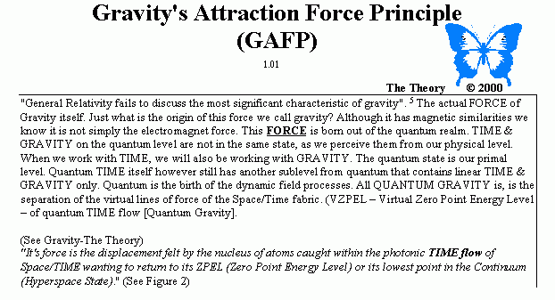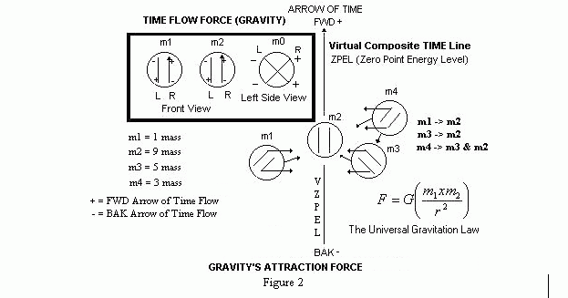
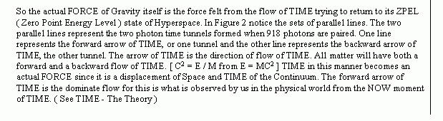
5.0 COMMENTARY ON DILATION

5.1 This author finds Dilation is something presently that is not being taken into consideration when dealing with relativity. The time frame (B_{N}) and space-time dilation must also be taken into consideration, when dealing at the quantum level. The author will point out later how important this single factor is when viewing the quantum realm. The author feels this is the main reason for the strangeness found at the quantum level.

5.2 Space is the infinite area, which resides in our present TIME FRAME ( B₀ ). Remember, no two objects (M₁ & M₂) can occupy the same space at the same time. If matter, space and time are forced to try and occupy the same time and space, that matter must give up its energy which it does in the form of heat, light and acceleration (Force). This is one of the secrets to obtaining critical mass for E=MC².

6.0 DEFINITION OF THE GRAVITY FORCE

6.1 Gravity FORCE is not a new concept and is talked about by many scientists, such as Dr. Wheeler.² The underlying FORCE however, is better known in current science as ZPE (Zero Point Energy). The author will expand upon this level for definition and clarification. The author states that Quantum Gravity FORCE is VZPEL (The Virtual Zero Point Energy Line).

6.2 Quantum gravity is synonymous with the level of zero point. The state of its existence in mathematical terms can be calculated with a family of closed looped vectors (Closed curved or Scalar). On the quantum level this force is just called a “ Gravity Force “ while on the physical level it is known as a “ Gravitational Force “.

6.3 It may be possible to engineer quantum gravity when it is understood. The author claims this should be the same lines of force what give birth to what is called String Theory. Again, the author will address this point later.

7.0 THE VIRTUAL LINE

7.1 How does one picture a virtual line? Magnetic fields are composed of virtual force lines. This does not imply that gravity, quantum gravity and magnetic fields are the same thing. Nor does it imply that these phenomena are of exactly the same nature, for they are not. They only display some of the same properties related to patterns and fluid dynamics.

  - You will notice the similarities in the equations for gravity and for magnetic fields below.
This indicates they are linked in some manner or fashion. 4D Unified Math will help expose that exact link through the two independent field’s shapes and patterns. Compare those patterns very closely below:

Universal Gravity Equation Magnetic Field Equation
Spacial Orientation Durational Orientation
Total Area Vs. Point Source
SPACE TIME
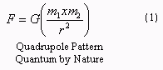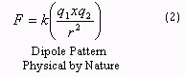
8.0 GRAVITY DESCRIPTION
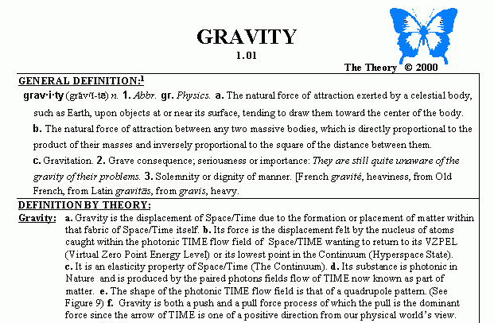9.0 UNIVERSAL GRAVITATIONAL LAW GRAPHIC
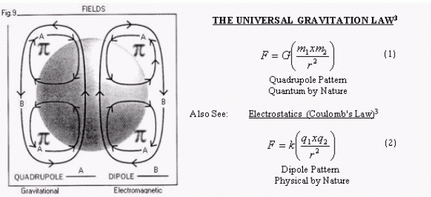

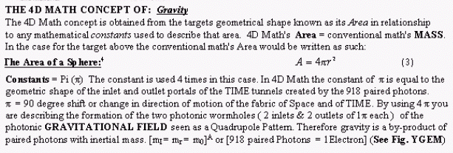
10.0 PERCEIVED KNOWLEDGE COMMENTARY

10.1 This author will attempt to explain the quantum strangeness below. The author will discuss Dilation, what it is and why it seems to do what is observed. Keep in mind Dilation is a real phenomena and has already been confirmed to exist. The author feels this one aspect alone is one of his biggest “ FINDINGS “(discoveries or realization - perhaps a prize winning one) about the quantum realm dealing with its already calculated properties. Measurements of single particle intrinsic spin are in complete agreement with this finding. Please make note the use of the word “spin “ is misleading when talking about dilation. A more proper identity would be intrinsic rotation which is dealing with the targets physical surface motion. As our technical editor has pointed out, when talking of spin, factors of motion and speed taking place from center point to surface come into play. We are only concerned here with the targets surface motions degree of rotation compared to the intrinsic surface rotation. Again we detect this intrinsic motion by the magnetic moment of the particle. Current science has coined the term spin so it shall stay. This author will use the term spin as currently accepted.

10.2 This discovery has already been confirmed and measured at the atomic level, and within the quantum domain. The author feels this finding has the ability to change the course of future space exploration, by opening new doors. Until now these doors have been locked by nature, due to a lack of full understanding of the quantum world. Space/Time dilation taking place at the atomic and quantum levels is the answer to most of the quantum strangeness as it is called that is found at those levels.

11.0 DEFINITION OF DILATION

11.1 Dilation is the phenomena that takes place when an object in motion (M₂, B₁) is view from the reference point of an object at rest (M₁, B₀).

The American Talking Dictionary defines dilation as:
di·la·tion (dº-l³“sh…n,d¹-) n.1.The act of expanding or the state of being
expanded³

12.0 COMMENTARY ON INTRINSIC SPIN

12.1 This author feels that the reason we see such strangeness on the quantum level, is that space and time dilation are taking place. This is based on what is called intrinsic
Spin of the particle. For those of you that are not familiar with just what intrinsic spin of a particle is, the author will take a moment to explain below.
12.2 It is a known and measured fact that particles have what is known as intrinsic spin to them measured by their magnetic moment. A photon for example has intrinsic spin of 1 which is equal to our physical level rotation of 360 degrees. For the electron however the intrinsic spin is that of one half ( ½ ). Translated into degrees, intrinsic spin of ½ equates to 720 degrees of rotation. We know that a physical particle on our physical level can only rotate one full rotation of 360 degrees. Therefore at our physical level 720 degrees of rotation equates to two full rotations of 360 degrees on the quantum and atomic levels. The author’s finding is that at relativistic or near relativistic speeds on the atomic level,” ACTUAL SPACE/TIME DILATION IS TAKING PLACE”. This is a tremendous realization with far reaching implications.

12.3 This would answer why we see 720 degrees of rotation for the electron in its B₁ time frame. This equates with 360 degrees from our viewing reference point of B₀ time frame. Tests have confirmed dilation takes place between a stationary viewing point and a moving point. This indicates dilation should be found at the atomic levels, when particles move at near relativistic speeds. No one the author knows or has heard of has considered this. This is why the author feels this is such an important find. To date, man has been looking at distant objects in space for signs of dilation. Yet dilation has been right here all along on the atomic level.

12.4 Degrees, angles and Pi are the core of what this paper is all about. It is important to understand how this is linked together, and how man can use it to engineer time. This should be our first steps in the direction to true warp drive engineering. Not using sheer velocity for travel, but actual control of space and time. If this thought does not get some of you excited, then perhaps you have missed the major points or “missed the boat” as some may say.

12.5 To give an illustration of TIME Dilation within the same base time frame, the author will
use our basic electron once again. We will later use it again to illustrate spacial dilation. The electron represents physical matter, as viewed from the basic B₀ Time frame. For clarity, the author will use the Bohr Atom concept as an example. In reality, the atom is more like a cloud of orbiting and changing electrons around a nucleus. In the example below, note the position and direction of the movement marker on the electron. It is depicted by the arrow and small square on the electron with motion illustrated by shaded halves.

12.6 M₁ is our physical mass, the proton (nucleus for our hydrogen atom), and M₂ is our physical mass the electron in orbit around that nucleus. Pay close attention to the time lines formed by the dilation between time frames B₀ and B₁ at the top of the drawing.

  - RELATIVISTIC TIME DILATION ILLUSTRATIONS

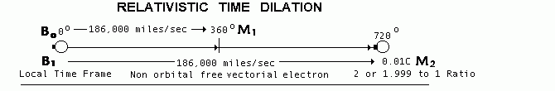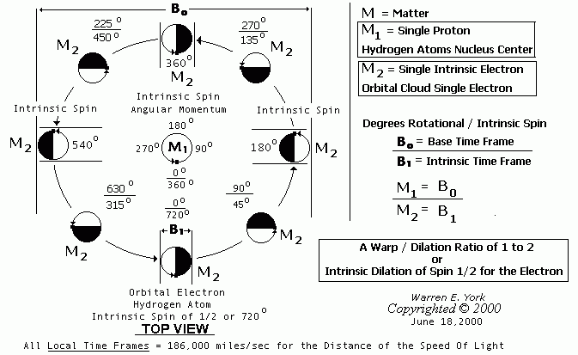
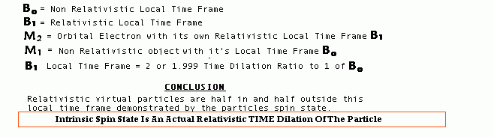
13.0 DEFINITION OF TIME FRAMES

13.1 Dilation is based on what are called Time Frames. The symbol used for Time Frames is the letter B.⁴ The NOW is shown as B₀, and represents our base or present time frame that we reside in and perceive as reality.

All Time Frames are based on the constant for the speed of light.
13.2 Since the constant never changes as indicated by Albert Einstein, then any change in that distance and not the constant will lead to a new time frame or ratio for B_{N}. It is important to understand this concept, since the constant never changes. Any distance (spacial ratio) change will give us a new distance for the speed of light ratio or Time Frame. That makes the distance of the speed of light (a ratio) different from the constant speed of light (a constant). The Constant speed is fixed and never changes. However, the Distance of the speed of light becomes a variable and its ratio can and will change. This change in ratio is what we call and perceive as space time dilation, or a new time frame (B_{N}). It is extremely important to grasp this concept.

13.3 The following graphic⁵ is the author‘s attempt to illustrate the abstract concept for Time Frames. The author will use the electron again as stated above for this visualization. One could also substitute the earth or any other planet and its spacial surface area for this
illustration. The important point here is to show a physical area or surface in its spacial
Environment.

- SPACIAL DILATION
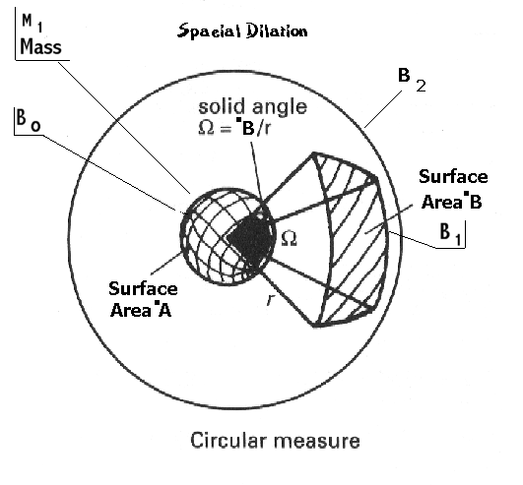
14.1 In the illustration, B equals a single time frame. Our present time frame is that of B₀. Each time frame (B) has its constant speed of light being 186K miles/sec. The only difference between any two B_{N}’s are their ratios for the distance of the speed of light. Notice the surface area for B₀ time frame ( Surface area A). It is less than that of B₁ time frame, surface area B.
  - Keep in mind the speed of light for both areas is still the same constant while the distance or spacial surface area, (the ratio), has changed. This is spacial dilation. Also keep in mind as in the illustration drawing for time dilation above of the hydrogen atom, that we can have many time frames within a single time frame. This is the reason we get an intrinsic spin of ½ (or 720 degrees) for our single particle electron when viewed from our B₀ frame in its physical single rotational limit of 360 degrees.

15.0 COMMENTARY ON SPACIAL DILATION

15.1 In our illustration, the surface area can be that of an electron or any planet for it does not matter. The illustration is to show the spacial dilation associated with different Time frames. We use M to indicate matter and our surface areas in the time dilation drawing of the hydrogen atom. The author has tried to stay constant in using a sphere or ball throughout the illustrations as our electron for better clarity.

15.2 Picture yourself on the surface of our planet Earth for time frame B₀ which is surface area A. Within this time frame and upon this same surface area all the current rules and laws take effect. The speed of light, the constant, is still 186K miles/sec and the distance is its equal. Now let’s take a space-time hyper-jump to our next time frame which will be surface B or time frame B₁. Everything still from our new perspective B₁ seems to be the same without change. The speed of light, the constant again, is still 186K and that distance is still its equal. What has changed?

15.3 From our new perspective nothing has changed but if viewed from our original B₀ the distance for the speed of light will appear to be greater. One mile in B₁ from our spacial reference will now seem greater in B₀ from that same vantage point of B₀. Everything, all mass and distances, will appear to have expanded. This brings out a very important point in relativity. Notice I stated it “appears” to have expanded. It is said as the speed of the object increases to the speed of light, the objects mass will become infinite. In reality this is misdirection and is not what is taking place at all. What does expand to infinity is not the mass, but the distance of the speed of light. The ratio is what is changing. When a ratio for the distance of the speed of light changes, it also changes time frames.

15.4 When viewed from our stationary vantage point of B₀. We know this because actual distant deep space objects moving at the speed or near speed of light (measured by the red shift) without their mass becoming infinite as indicated by the math. This fact and error is due to the misunderstanding of the process itself. Mathematically explaining an object approaching infinity is an oversight. What people are forgetting is that the space between and around all matter (mass) is also expanding. Space/Time Dilation is taking place.

15.5 The ratio or distance of the speed of light is what is expanding to infinity and not just the object. This is spacial dilation as in our illustration above. Also notice compared to our illustration of the hydrogen atom time dilation, the surface area is not larger as in our spacial illustration, but actually smaller. This is due to the viewing of time dilation B₁ from within time frame B₀. As the spacial area is going into dilation, so is the new observed time frame B₁.

15.6 Imagine you are on the linear moving surface B₁ instead of a stationary surface within the same time frame B₀. From B₀ the mass will still seem less, but what is expanding to infinity is the spacial Time Frame and not just mass as currently thought. Notice if the Time Frame ratio is expanding to infinity it stands to reason the mass would also seem to be expanding as calculated by the equation. If you are on the moving surface you will not notice any real change. When compared with where you just left B₀ to the moving surface B₁, then there will be a real change and difference.

15.7 If you are on the moving target, all goes on as normal. When you return however you will see there has been a real time change take place. This contradicts reason! What about the spacial dilation? As you return the spacial dilation will return to the basic point it left, and only the time will remain different. The spacial factor will always try and return or stabilize to a ZPEL point. This elastic force of the ZPEL is what quantum gravity is all about. When the spacial dilation is in effect, the object is in a hyper-jump state of existence; again as our electron is when it makes it hyper-jump by tunneling. The spacial factor of Space/Time is the elastic part of space time. This spacial part of space/time is always seeking its ZPEL.

15.8 Remember that what you can do with one of the factors, can also be done for the other. This is what warp technology is all about. Moving through TIME and SPACE with no time in transit from point A to point B. A true hyper-jump is possible as I just pointed out with our electron. As the author has also already stated above, science calls this known fact of a hyper-jump by the electron, “tunneling”. Nothing presented here breaks any laws, or contradicts what has already been measured with present science. Understanding the process is the key. Understanding just what time and its components are, plus defining time is essential to understanding this technology.

16.0 LINEAR MOTION VS. FIXED STATIONARY ORBITAL MOTION DILATION:

  - Consider measuring an object moving in B₀ time frame with a linear motion instead of
fixed stationary orbital motion. Our electron has a time frame B₁ within the same time frame B_{0.} The object, a moving box in this case below, will still be less when measured from B₀ but having no change when actually viewed from within B₁ on that moving object (box). This is because the ratio for the distance of the speed of light in B₀ (Z-axis) is warping 90 degrees into its new time frame B₁ (Y-axis). Again, if you were on or in that moving target (the box) you would not notice any change in spacial or your local time. This is because dilation is taking place. Remember Einstein’s relative motion train and the falling elevator examples? Without a reference point outside the Space/Time Frame under dilation one would not be able to detect any changes taking place. Just like the falling or rising elevator. One could not identify gravity from inertia without forces of change or outside observation. Spacial Historical evidence of this is from where man once thought the Earth was flat. What seems is not always what is in reality.

16.2 LINEAR MOTION GRAPHICS
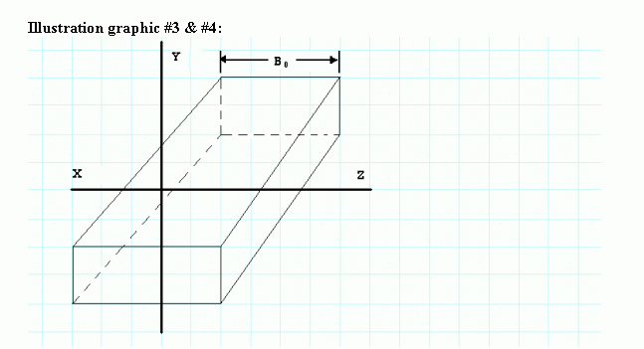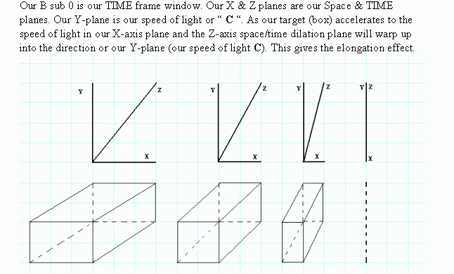

16.3 The illustration above shows dilation (warping) taking place as it is viewed from the stationary observation point of B₀. Notice how the object seems to become shorter in length with respect to the direction of motion. This is exactly what has been measured and found in test performed and also predicted by Albert Einstein. He said the object will appear to elongate.⁴

16.4 Another way to view this same linear dilation is in the diagram below.⁸ Notice how the object (target) seems to close in on itself (implode) as it exceeds the speed of light from time frame B₀. The conclusions about Space/Time is that they are both based on the speed of light. This is claimed in the author‘s Unification Field Theory ( The Final Theory) and proven with the use of Pi.
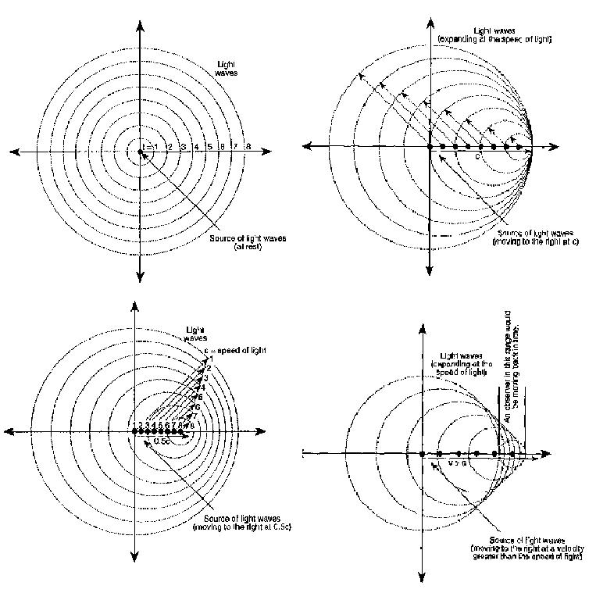

17.0 ARITHMETIC Pi DEFINITION

17.1 Now that we have some of the pre-requisites out of the way, we can get on to the main subjects of this paper. This is the core subject of this paper. The first principle we will cover is Arithmetic Pi. And the second principle we will cover will be what is called Trigonometric Pi.

17.2 Lets look at Arithmetic Pi however before we move on to the later. Arthmetic Pi represents our physical present matter reference point B₀. In this present existence all the shapes and patterns both seen and unseen are based on its laws and conditions. The basic of these shapes is based on GRAVITY and takes on the shape of a ball or sphere. If you doubt it just look around at the heavens. This is the standard basic shape taken on by matter when it is free to form in its basic state. The forces (gravity mostly) determine this shape. Go back and look at the forces and fields that must form this round shape in the graphic on gravity. This shape is mathematically bound by what we call Arithmetic Pi.

It has been established Arithmetic Pi has a numeric value of:
3.141592653589793238466264338327950288419716939... and so on to infinity.

17.3 All numeric numbers are a direct translation into some shape or patterns with the scale determined by a numeric amount. Arithmetic Pi uses arcs and presents an overall image of a circle in 2D space. Pi will always be associated with a circular shape. All a circular form is when completed is one big arc that comes back on itself (what the author calls closed looped or better known as closed curves in main stream science) forming a circle. Now the numeric values may indicate different scales by amount but the end pattern will always have a from of a circle in it. The 3D level for arithmetic Pi is that of a ball or sphere. Now our 4D level will allow the extra dimension of change of position better known as motion over duration or Physical Time.

18.0 PHYSICAL TIME DEFINITION

18.1 Time on the physical level is considered change of position (motion) over space measured by distance or duration.

18.2 This author has found that there are two basic forms of time. One is our present
Physical level time which we call chronological Time. The other form is the quantum
level of time which is also based on Pi. Pi MARKS the intrinsic spin of the particle. Quantum time turns into present level Time due to Pi and the equilibrium equation when equal to zero. The plot of quantum time is where man has presently hit a wall with current technology. This wall is known as the Heisenberg Uncertainty Principle. This need not be a blockage any longer once dilation and quantum Time are fully understood. Understanding that dilation is taking place is the key. Quantum Time will be measured not by position in space but rather by position of rotation for Pi. Physical Time at the quantum level is omnipresent. That is to say it is all of Time both past and present. This is a true hyperspace state of existence. A very real place and yet Time flows both forward and backwards as compared to our present physical level of only forward motion perception. Hence the reason 4D Unified Math has no negatives and yet Time can and does flow backwards as well as forward all at once.

18.3 Lets consider calculating quantum time by the equilibrium equation. When equal to zero, quantum time transforms into what we now call present time or a single point in our Minkowski space time Geometry. The target (planet, electron, etc.) “thinks” it is at the center of the universe and becomes that point. Once we move that POINT from point A to point B we then have our present time derived from distance over motion. You should start seeing the connection between Pi and this elusive Butterfly man calls TIME. Now let’s look at Arithmetic Pi and how it is connected with both present physical time and quantum time.

18.4 Physical Time from the quantum level is due to the Rotational Equilibrium Equation as stated above. This however is based on researchers Unification process ( The Final Theory ) which is not to be covered in this paper. Physical TIME can also consist of non-change with just the duration factor. Although duration is a set reference mark, it is man who assigned a reference point for measurement. This is known as physical or chronological TIME. This motion or duration reference was originally set to the motion of the planets.

18.5 Example: A measurement of one day being the chronological TIME Earth orbits our Sun. One day which is further broken down into 24 hours equals day… so on. Now you should start seeing that our physical 4D level shows time and has a part to play in the composite dynamic view. Now the key is duration of change or non-change. This however is still an ambiguous form of measurement we call TIME. As it stands alone, TIME still can not be taken into the lab and engineered. In this form it can only be used as a system of recording records of events over duration.

18.6 This results in a virtual, consistent reference mark. Now keep this word "mark" in mind for we will be using it again when we discuss what quantum TIME is in relationship to Pi. So on the physical 4D level, Pi takes on the shape of a sphere or ball in space-time. For example to find the area of a sphere (ball) the equation is A=2Pi r squared. Notice the formula has Pi embedded in it? To figure the volume of that shape one must use our arithmetic Pi in its calculations. I stated the 4D Unified Math process view is that of shape or pattern. The actual base root of 4D Unified Math is light.

18.7 Going into the process of 4D Math however is outside the scope of this paper as I have mentioned earlier and will be covered in a later paper dealing with the process alone. The actual process is not important to us at this time. What is important is for you to see how shape and Pi are linked.

18.8 Consider the free form of matter (not influenced by and external gravitation form or other forces) like that found in outerspace. In space the shape matter will take is due to its own gravitation field (or force) and is that of a sphere. Notice the connection between gravity on the physical level, and Pi. Using 4D Unified Math we can back engineer nature and unlock her hidden secrets. This consists of physical time and gravity, and quantum time and gravity. I hope at this point in the paper you are starting to see the importance of these connections and the excitement of what they may yield.

18.9 Our 2D circle dictated by Pi is a closed loop (closed curved) bent line (ark or curve) which can be divided up. These are divided into degrees of angles and curves in our physical level. At the physical level we have 360 degrees for one complete cycle. We also divide this same 2D circle on our physical level into our chronological minutes and hours, as on the face of a clock. A digital clock is simply a numerical record of the same duration measurement system. Remember the numerical view does not give us the dynamics of the overall view. It is only a measurement of recorded reference points.

18.10 Now these reference points can be reviewed as past points or calculated as future points. Again they are only virtual measurement points without substance of structural engineering. Like the authors 4D Unified Math, the collection of these duration records are based on the "Distance of the Speed of Light". This is called a "TIME Frame" and arithmetically labeled as B₀ as you already know. Anything greater than B₀ is a different TIME Frame B_{N} as discussed earlier.
19.0 POSITIVE AND NEGATIVE TIME FRAMES

19.1 For all practical purposes there are no negative Time Frames. All other TIME Frames greater than B₀ simply have a different ratio for the "Distance of the speed of light". In all TIME Frames however the speed of light remains at a constant 300 kilometers/sec or 186K miles/sec value. This is saying that the only difference between TIME Frames is its Space/Time ratio. Depending on that ratio and from which TIME Frame one is observing in, the ratio may be forward or backward in reference marking of the chronological time measurement. Any change in ratio from our B₀ Frame is known as dilation. Once again Dilation is a real factor and has been observed to exist both mathematically and physically. All this by the way is derived from our 2D circle constructed from Pi.

19.2 REVIEWING Arithmetic Pi:
Arithmetic Pi at the physical level
1D = an arc ( 360 degrees B₀ )
2D = a circle
3D = a sphere
4D = Duration (chronicle TIME)

20.0 Quantum Time Unit Base Ten of Arithmetic Pi for Intrinsic Particle Spin 1/2

20.1 The Electron
LAW OF SIGNS (180 degrees)

Quantum Particle’s Particle Spin 1/2 Quantum Time
Time Unit Degree of Intrinsic Spin (Pi) = Intrinsic Pi
1/10…….…….. 72 ………………… 1.2566 ………………… .4
2/10….……….. 144 ………………… 2.5132 ………………… .8
3/11…………… 216 ………………… 3.5132 ………………… 1.2
4/10…………… 288 ………………… 5.0264 ………………… 1.6
5/10…………… 360 ………………… 6.2831 ………………… 2.0
6/10…………… 432 ………………… 7.5396 ………………… 2.4
7/10…………… 504 ………………… 8.7962 ………………… 2.8
8/10…………… 576 …………………10.0528 ………………… 3.2
9/10…………… 648 …………………11.3094 ………………… 3.6
10/10…………… 720 …………………12.5663 ………………… 4.0

20.2 Arithmetic Pi usually deals with the physical world as a general rule but has a crossover to the quantum world through Trigonometric Pi. Notice that quantum time above is a unit of measure (scalar). It does not show position as in agreement with the Heisenberg Uncertainty Principle. Now we can measure quantum time in degrees for an intrinsic Pi “MARK” for the spin of the particle both spin Up and spin Down. Alter intrinsic spin and you alter quantum times dilation. This brings us closer to the first step, to generate large amounts of anti-matter freely. This also creates a new field called “Spintronics” ⁶ which has applications in microelectronics. Up spin state can represent “ 1 “ and Down spin state can represent “ 0 “. Couple this with inverse entanglement and you have possible FTL (Faster Than Light) communication. To conclude, quantum time is measured in degrees of intrinsic Pi. Intrinsic Pi is the state of Space/Time Dilation observed in B₀ < or > of B_{N}.

21.0 TRIGONOMETRIC Pi DEFINITION

21.1 At this point, we need to define trigonometric Pi. trigonometric Pi is based on the law of signs. If we take a straight line and fold it over into a closed looped configuration, we will have a triangle in its basic and simplest form. Like Arithmetic Pi, trigonometric Pi is formed as a closed ended configuration of a line bent into smaller lines forming at least three angles. The law of signs states that the sum of all the angles needed to form the closed looped configuration must always add up to the sum of 180 degrees.

21.2 So instead of dealing with degrees of arc as in arithmetic Pi, we are now dealing in degrees of angles for trigonometric Pi. This will convert from trigonometric Pi to arithmetic Pi, as you will see when calculating degrees, Pi and intrinsic spin of a particle.

21.3 There exists a simple method to get trigonometric Pi which is based on straight lines, angles and the law of signs. At the quantum level, the author has stated the straight line represents VZPEL for our space/time Continuum Matrix. Consider closing the ends of a curve (closing the loop as the author calls it) of a straight line back onto itself This would form a triangle with the sum of its three angles always having the sum of 180 degrees which results from The Law of Signs.

21.4 TRIGONOMETRIC QUANTUM TIME GRAPHICS
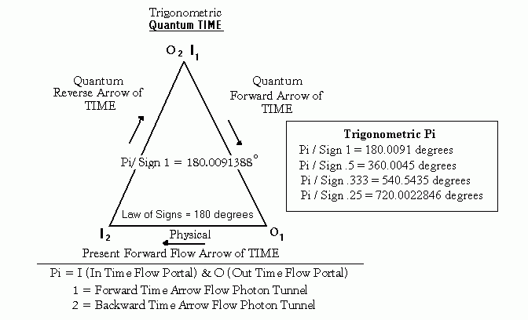

21.4 (cont’d)
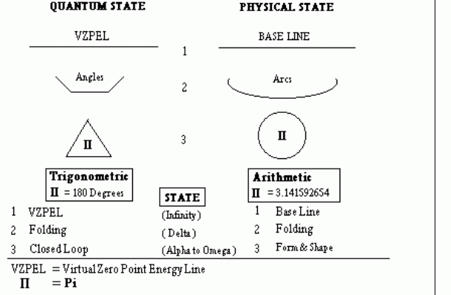
REVIEWING TRIGONOMETRIC Pi:
Trigonometric Pi is of the quantum level.
1D = a line ( VZPEL ) Space/Time Dilation B₁ residing inside B₀.
2D = an angle
3D = a triangle
4D = scalar vector flow (quantum time flow) Forward and Backward ( C² )

22.0 STRING THEORY

22.1 As stated earlier in this paper, the author stated he would indicate how string theory relates to the new theory. Details of exactly how String Theory plays a part, would involve the author‘s “Final Theory” concept which is not a part of this paper. The intent of this paper is to stay strictly with observed phenomena and facts already established. String Theory is covered below for illustrative purposes only.

22.2 To date, current String Theory has had one great obstacle. String Theory has lacked a “ home “ in which to exist. Consider this thought: How can we have an infinite number of minuscule, vibrating strings throughout space-time, without any process to support the existence of these objects?

22.3 As an example, an atom has structure. An atom is considered a separate entity made up of other particles, and this “ home “ is what we call the actual atom. The atom’s home has its own domain and can always be found as that entity. We do not find strings or threads just running about free, unless there is a process taking place allowing this. Strings are thought to be inside other structures, according to theory. These are not actual strings themselves but rather force lines (VZPEL the author claims) which are plotted by particle paths after collision. String Theory is the best Theory of Everything we have up until the author’s release for his Final Theory. Empirical evidence for String Theory is only based on cloud chamber and high speed interactions of particles with mutual collisions. This process as we know it is the result from particle decay. Angles and sub particle trails all indicate the underline pattern of String Theory. This author’s YGEM (York, Geier Electron Model) has the exact same results. It also explains the underlying process that forms the patterns.

22.4 STRING THEORY GRAPHIC
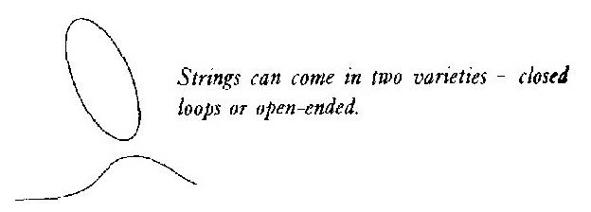
22.5 Vibrating, wiggly, squiggly strings and loops are in reality, not as symmetrical as seen above⁷. The loops actually twist and cross at times giving the impression of the helix form. This is not to be construed as actual DNA structures but only taking on at times the action or motion of a helix pattern. The actual force behind the DNA helix structure will be covered in a separate paper dealing with the biological factors. The next drawing is a zoomed in view of our squiggly string (Force Lines) crossing each other. This is the most common structure found in string theory. Keep in mind the strings and threads are Force Lines (VZPEL-Quantum Gravity).

22.6 Helix Strings Crossing Pattern

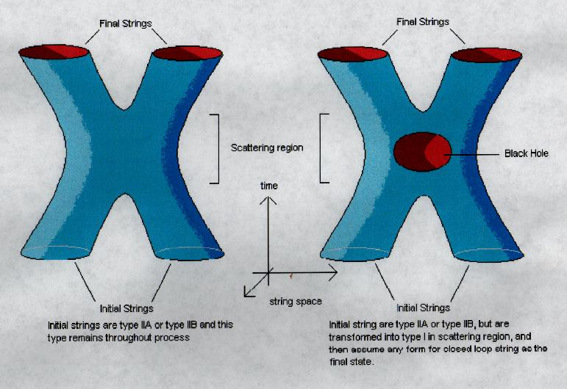
22.7 This helix or crossing pattern is explained in the author‘s “ Final Theory.” This will not be discussed in any depth within this paper. That will be reserved for a later paper, devoted strictly to Final Theory. The issuance of the Final Theory paper will depend on the interest generated by this paper. It will explain in detail the patterns found in String Theory.

22.8 Consider the open-ended string or “ Thread “ as the author calls it. This is formed by only one source. That source is a photon. Now by doing a little advanced thinking you will see that the closed looped wiggly lines are formed by paired or entangled photons. The actual photon configuration however, is not as simplistic as the drawing above indicates.

- STRING THEORY DOMAIN

23.1 Next, we will show the domain or place in which String Theory resides. This is required to give it a reason for existence or being. This domain comes from none other than Quantum Gravity or the VZPEL. It is the “glue” of the atom. Its domain comes from the photon as a thread, and resides in higher particles starting with the electron. The electron is the first transformation of energy into matter accordingly to the author based on that theory. Again the author calls that new electron model the YGEM.

23.2 What the vibrating strings actually consist of, can be seen in the drawing above. These are closed looped and have two quantum gravity lines of force. Strings also have forward and negative time flow, with omni-present time (or hyperspace) structure. A single thread (open loop) is found only in the photon. When two photons become entangled or paired, they form the closed looped vibrating strings we find in string theory. Remember the VZPEL is a quantum gravity FORCE found in all particles and matter there of. This also holds true to the claim of String Theory.

23.3 The only factor which the author has added to String Theory, is the process for its existence. Like the particles in an atom, it must have a home, which we will call the domain. The author has added to String Theory a stand alone component of String Theory called a THREAD. A single line of force (VZPEL) and found in every photon. The author hopes he has given the reader food for thought and encouragement. There are still further unknowns waiting to be found. This enigma is far from over. This new theory is but man‘s first real steps to the Stars.

23.4 When viewing the YGEM ( York, Geier Electron Model )^{A} the domain for String Theory will become quite clear. The Final Theory” paper will be issued pending interest in this paper as stated above. This theory is one based on light. Not a new age theory but one based on
our present physics foundation. It stands on the shoulders of others that have come before.

24.0 EXAMPLE – UNIFIED MATH APPLICATION
24.1 One can not expect to use 4D Unified Math in order to obtain energy calculations directly. To understand the full 4D Unified Math process, the reader will have to wait on the posting of the paper dedicated to that process. The calculations 4D Unified Math produces are derived from shape and patterns. This is the geometry aspect described earlier in this paper. These are formed by the forces acting on the object. The results obtained will not yield direct energy results. Indirect results obtained are resolved using standard mathematics. Use of 4D math removes some of the uncertainty, which is present in Heisenberg’s Uncertainty Principle. An example of the using 4D math is shown below in 24.1.1

24.1.1 The following two equations express the current Heisenberg’s Uncertainty Principle.⁵
Equation 1: ∆x ∆p_{x} ≥ h/4 Pi ~ h/Pi
Equation 2: ∆t ∆E ≥ h/4 Pi ~ h/2 Pi

h Planks constant
∆x Change or uncertainty on the X-coordinate of position for the particle
∆p_{X} Uncertainty in the X-coordinate of the momentum. ( Same for y and z components)
∆t Uncertainty in quantum time
∆E Energy uncertainty

24.2 Fundamentally, 4D Unified Math is based on constants and powers of ten. The information presented in this paper and its relationship with Pi removes the uncertainty for ∆p_{X} in equation two. It is replaced with intrinsic angular momentum value of Pi presented in equation one above. The equation still will not give us position of the particle ∆_{X}. It would however, put us half-way into solving for ∆E. This is the uncertainty in the energy. What it does provide is ∆t, the uncertainty in the quantum time for equation two. Take notice both equations are based on Pi.

24.3 This application was not worked out previous to the printing of this paper by this author. However, the 4D Unified Math still holds true to its claim as one can see. This author has not been able to determine the limits of 4D Unified Math. It provides a powerful tool for Relativity Research. One may also use it in every day visualizations, such as mapping a Gravity Field.

24.4 This author leaves the exploration of the possibilities to the reader. Go back and see if you can spot how 4D Unified Math was used in Sec. 9.0, the Universal Gravitational Law graphic. The gravitational field pattern was named by the author and his associate, as "The Butterfly Pattern".

24.5 4D Unified Math has been used by the author to extract both time and gravity on the physical and quantum levels from the basic equation E=MC². For those of you that wish to ponder further, this author will supply what both he and his associate feel is the Final Equation. That little over one inch long equation some are looking for called The Unified Field Equation. The equation which ties everything on both the physical and quantum level together. It leaves nothing out to question once understood with use of the 4D Unified Math process.
Equation 3: E=MC²::E=MC*^{<-2->}

(Based on Theory and confirmed with 4D Unified Math)
^{UNIFIED FIELD EQUATION}
25.0 CONCLUSION

25.1 Consider putting Trigonometric Pi (the triangle), quantum level, inside our Arithmetic Pi (the circle.) On the physical level, we get much more than Richard Hoagland’s Hyper-dimensional space concept. We get actual linkage to a true Unified Field Theory (The Final Theory) which can be engineered for a useful purpose. Perhaps a culture did exist many light years before mankind did. Or, maybe the data gathered from the Mars face is just a trick of shadows and nothing more.

25.2 The following image^{B} is taken from Richard Hoagland’s excellent work on his Hyper-dimensional space concept. You must decide this for yourself. The author however is certain about the relationship that exists between the Unified Field Theory (The Final Theory) and Pi.
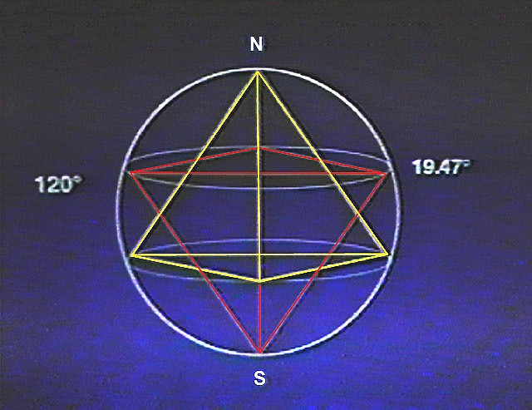
25.3 Standard mathematical theory fits perfect to current findings for the single particle theory based on Spin. With the aid of the authors 4D Unified Math, additional information has been extracted from that famous equation E=C². This paper for the most part is based on facts. The author has left most of the theory for another paper to come. Anyone reading this paper can check out the math for themselves. Even with this new theory, the results are in agreement with actual findings and measurements. This means understanding dilation and that it takes place right here within our present base time frame B₀.

25.4 Within our own base time frame, we can have any number of Time Frames residing with inside multiple Time Frames. The strangeness starts to fade away and man is one step closer to the Stars. By taking space-time dilation into consideration at the atomic level with individual relativistic or near relativistic speeds, we are able to start our first real work with warp technology.

  - By controlling the “ MARK “ we should be able to control the spin up or spin down of
the particle. One is 180 degrees opposite the other. This will assist man to produce anti-matter more efficiently. The spin down would create a negative quantum time flow, while the spin up of the particle results in forward flow. Physical time engineering will require a better understanding of the Unified Final Theory. This will presented by the author and his associates, in a later paper and from a series of papers produced here.

***
WARP TECHNOLOGY CHALLANGE
To reach the Stars man must master not only Space but also that of Time.
Mankind’s new and ultimate Space Race. Let the Race begin!

26.0 REFERENCES

1. “Three Roads To Quantum Gravity” by Lee Smolin, p218, Quantum Gravity
2. “Unified Physics” by Reginald Irvan Gray, p3-17, equation 3-54
3. “The American Talking Dictionary” CD-AMH744CE
4. “The Theory of Relativity & Other Essays” by Albert Einstein
5. “The Facts on File Dictionary of Physics” by John Daintith & Clark, p38
6. “American Scientist” Vol.89 by Sankar Das Sarma, Spintronics, p516
7. “Schrodinger’s Kittens and the Search for Reality” by John Gribbin, p230
8. “What is Time?” by John T. Nordberg, p100 and p101

27.O CREDITS

A. Charlotte Geier teamwork in development of the YGEM and Basic Final Theory
B. Richard Hoagland, permission to use Graphic taken from video of Hyperdimensional
Technology presented in lecture at NASA. Author of “The Monuments of Mars”
C. Ted Twietmeyer, support and technical editor of on going research project

CONTACT INFORMATION

Readers may contact both the author and technical editor at the e-mail address listed in the front of this paper and as seen below on questions or feedback one may have pertaining to the paper. All and any inquiries are welcome. All will be taken seriously for reply by both author and editor.

SERVICE INFORMATION

Readers requesting copies for distribution may contact the AUTHOR at the e-mail address below. Formats that will be made available are electronic Flip E-Book on CD, Word Doc (2002) CD or disk, Half Page folded booklets in hard copy or standard 8 x 11 hard copies both bound and unbound. PDF formats at present are pending. Palm and Pocket PC e-book format is under consideration. Request to be added to e-mail notification list on future releases are also welcome. Contact prior to all orders of copies required. All offers are subject to change without notice.

(E-mail address are hot linked when viewed on electronic media. Just click on blue.)

Author Warren York
pubmaster@charter.net

Technical Editor Ted Twietmeyer^{C}
tedtw@usadatanet.net

